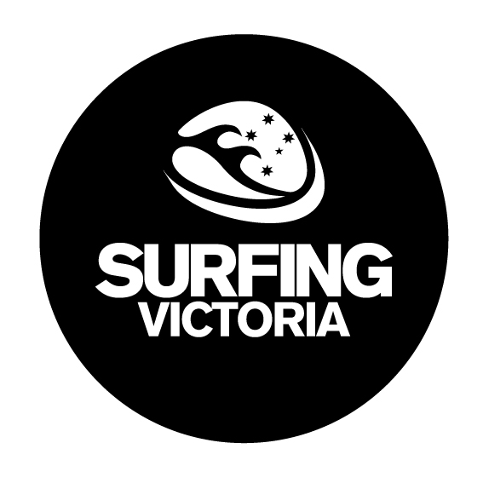
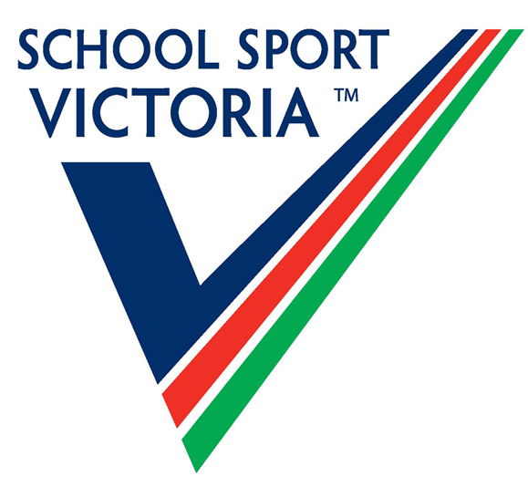

School Sport Victoria
Surfing Victoria

2019 Female State Schools Teams Title

Friday 10th May – Phillip Island
Team composition:
3 x under 19 Girl, 1 x Under 16 Girls (plus each team has a coach).
All ages taken from 31/12/2019. I.e. U19 must be born 2001 or later, U16 2004 or later.

Please note: the team can be made up of all Under 16 aged surfers if required.

Schools eligible for this competition include:
- Secondary Government Schools who have full membership with School Sport Victoria.
- Secondary Non-Government schools that have an associate membership with School Sport Victoria.

Please note. This is a secondary school competition only and competitors must be full time students.

Entries must be lodged by 5pm Monday 6th May to Surfing Victoria.
PO Box 230, Torquay 3228. Fax to (03) 52 614 460 or email info@surfingvic.com

Entry Fee: $66 inclusive of gst.

School Team Surfing

School Name: __________________________________________________________________

Address of School:_______________________________________________________________

Phone. No:_____________________________________________________________________

Name of coach:__________________________________________________________________

Email Address:__________________________________________________________________

Signature of team coach:__________________________________________________________

See SSV website for further information www.ssv.vic.edu.au or contact
Surfing Victoria on 5261-2907
Surfing Victoria Inc ABN: 59672903896

