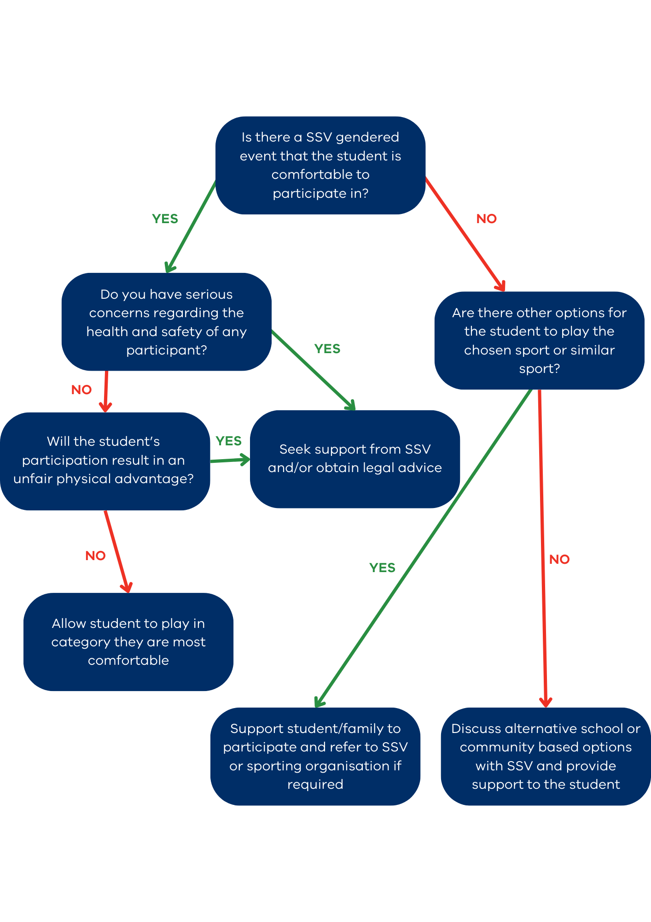
Decision making tool for trans and gender diverse student participation
Please read in conjunction with SSV’s participation guidance in SSV sporting activities for trans and gender diverse students available on the SSV website.

